2015 Desert Mountain Market Review

Prepared by

Davis Driver

July 27th, 2015





[Davis.Driver@bhhsaz.com](mailto:Davis.Driver@bhhsaz.com)

602 399 0116

Table of Contents

1. Private Party Custom Home Sales as a Percentage of all Custom Home Sales Page 3
2. Equity Golf Membership Home Sales, Custom and Semi-Custom Page 3
3. Sold Homes Analysis, by Size and Price Ranges, with selected features,

June 1, 2013 through May 31, 2014 (143 homes) Page 4

1. Sold Homes Analysis, by Arch. Style, M’ship. and No. of Bedrooms

June 1, 2013 through May 31, 2014 (143 homes) Page 4

1. Sold Homes Analysis, by Days on Market, Floor Plan Type, and

Direction Home Faces

June 1, 2013 through May 31, 2014 (143 homes) Page 5

1. Sold Homes Analysis, by View Ratings and Discount from List Price Page 7

June 1 2013 through May 31, 2014 (143 homes)

1. Sold Homes Analysis, by Size and Price Ranges, with selected features,

June 1, 2014 through May 31, 2015 (118 homes) Page 7

1. Sold Homes Analysis, by Arch. Style, M’ship. and No. of Bedrooms

June 1, 2014 through May 31, 2015 (118 homes) Page 7

1. Sold Homes Analysis, by Days on Market, Floor Plan Type, and

Direction Home Faces

June 1, 2014 through May 31, 2015 (118 homes) Page 8

1. Sold Homes Analysis, by View Ratings and Discount from List Price Page 10

June 1 2014 through May 31, 2015 (118 homes)

1. Sold Homes, by Price Per Square Foot Band, per Membership

June 1 – May 31, 2015 Page 10

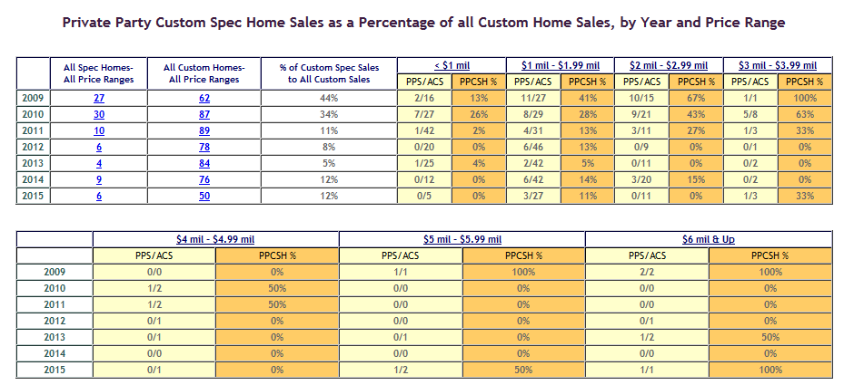



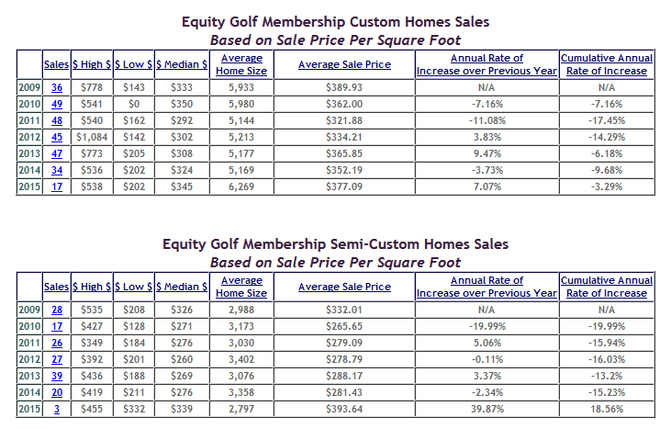

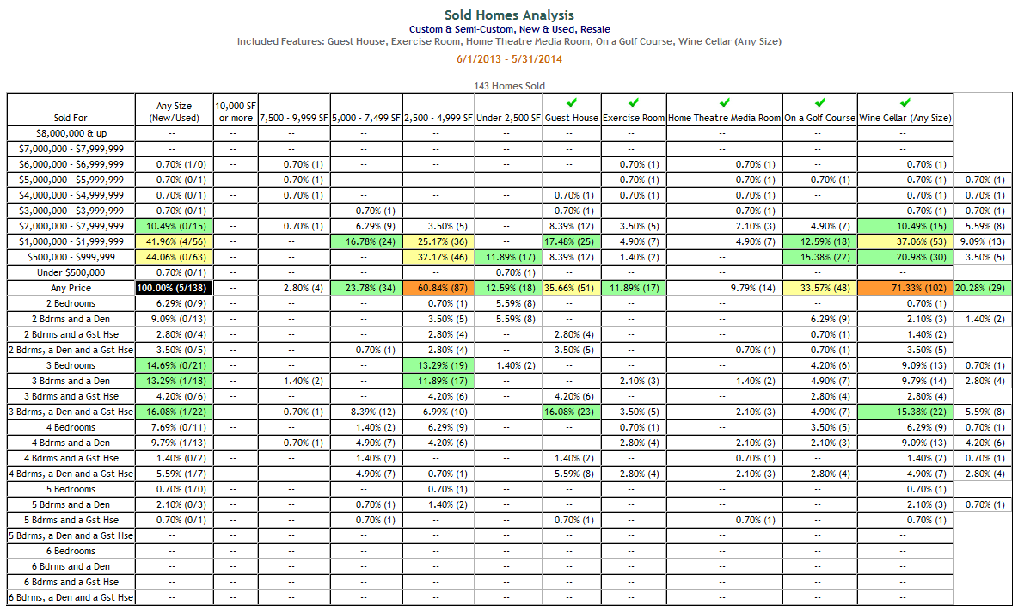

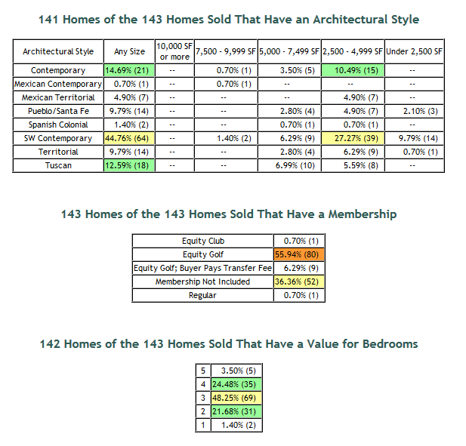

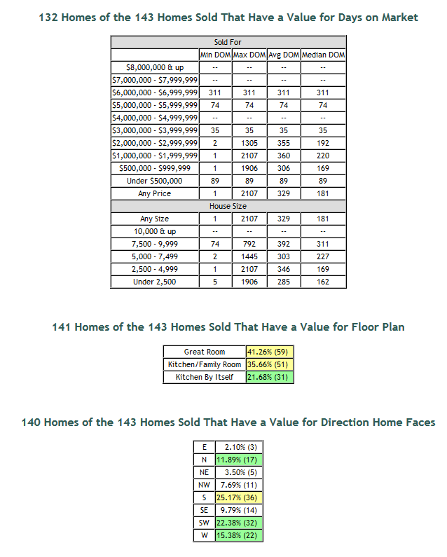

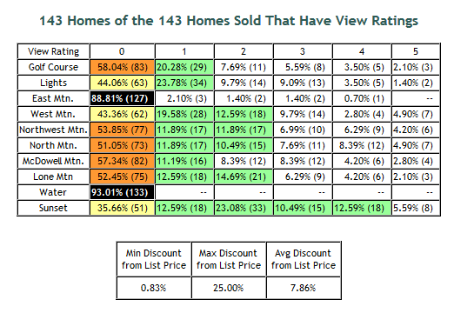

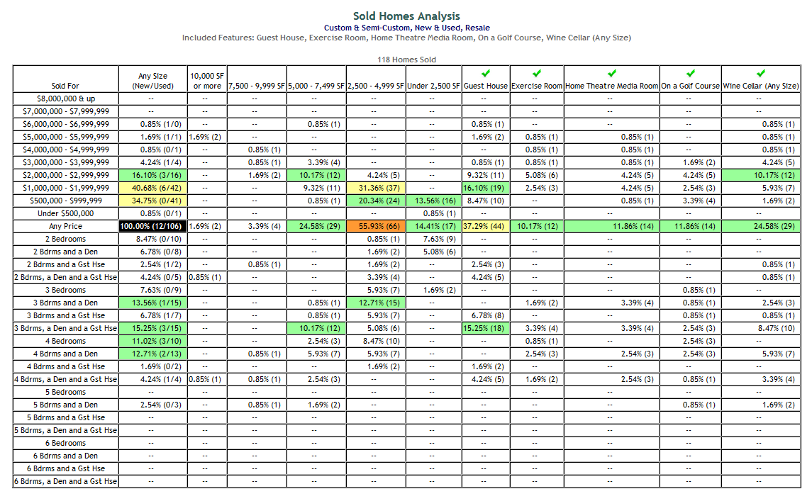

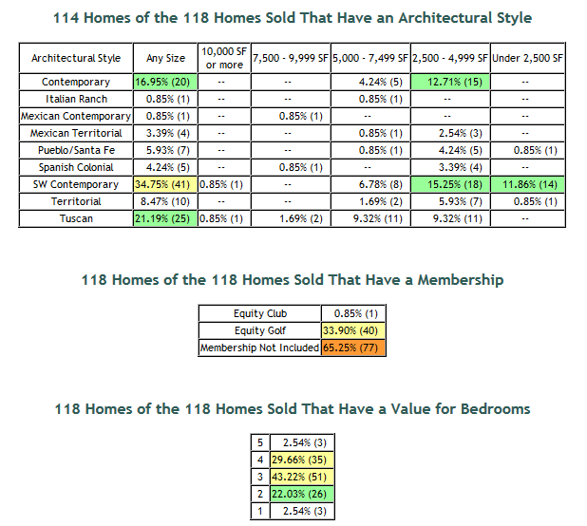

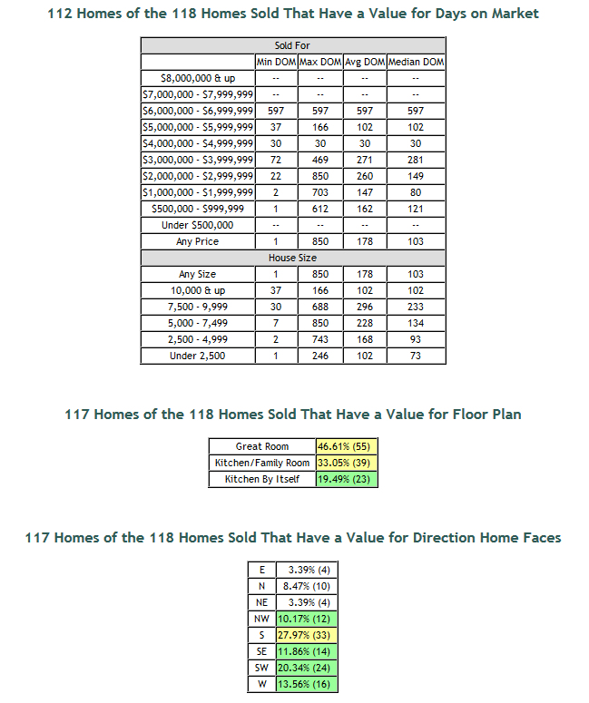

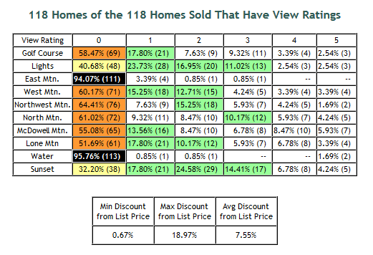

Home Sales by Membership and Price Band



1. 616 Homes Sold in Last Five Years
   1. Implication of Golf Course View vs. No Golf Course View
      1. 72 had Golf Course View Grades of 3 or better
         1. Average Price paid on 40 Sold with EGM: $382.12 (27.9% premium over 0 golf course view)
         2. Average Price paid on 28 Sold with No Membership: $336.66 (28.6% premium over 0 golf course view)
      2. 373 had Golf Course View Grades of 0
         1. Average Price paid on 182 Sold with EGM: $298.83
         2. Average Price paid on 174 Sold with No Membership: $261.70
   2. Implication of City Light View vs. No City Light View
      1. 114 had City Light Views of 3 or better
         1. Average Price paid on 73 Sold with EGM: $366.81
         2. Average Price paid on 38 Sold with No Membership: $339.98
      2. 274 had City Light Views of 0
         1. Average Price paid on 119 Sold with EGM: $278.31
         2. Average Price paid on 135 Sold with No Membership: $251.63